UNIT 7 – T+L (COGNITION, PT 2)
‘9-DOT’ PROBLEM
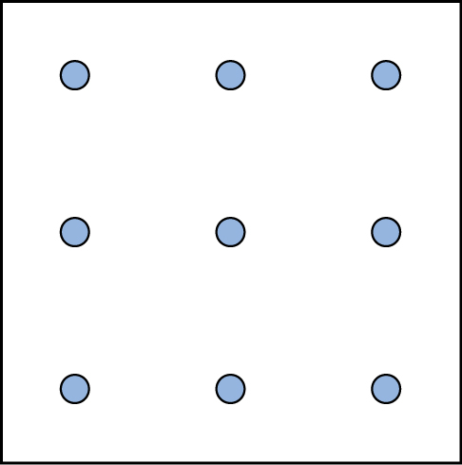
Directions – Draw four continuous straight lines, connecting all the dots without lifting your pencil from the paper.

