Name_________________________________________Block_______Date________
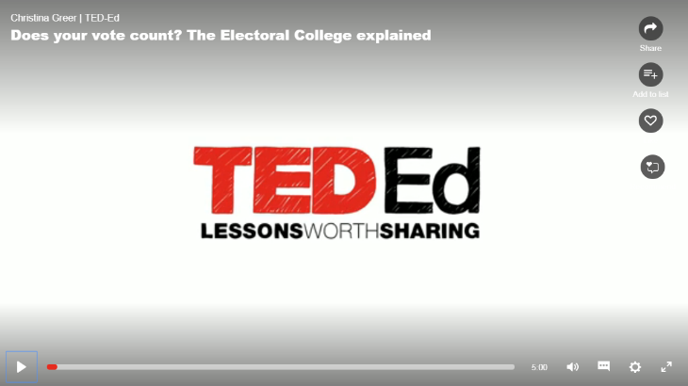
Does Your Vote Count? – The Electoral College
Directions – While watching the introductory video, write down at least two questions you have about the Electoral College.

Name_________________________________________Block_______Date________
Does Your Vote Count? – The Electoral College
Directions – While watching the introductory video, write down at least two questions you have about the Electoral College.

