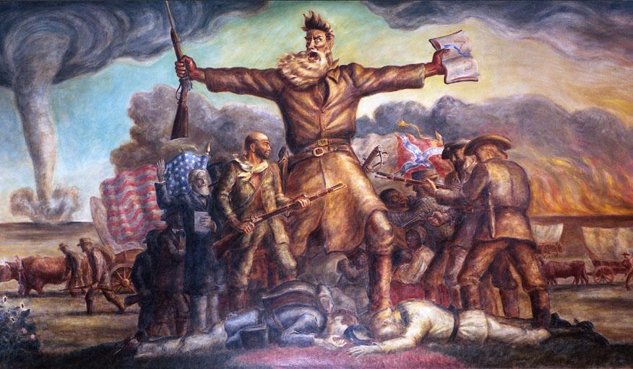
Name: _________________________________________________ Block: _______

Write down at least one question you have regarding the above picture.

______________________________________________________________________________

______________________________________________________________________________

______________________________________________________________________________

Write a paragraph about what you think the picture is about.

______________________________________________________________________________

______________________________________________________________________________

______________________________________________________________________________

______________________________________________________________________________

______________________________________________________________________________

______________________________________________________________________________

Give the painting a title: __________________________________________________________

