Name____________________________________________________________________________ Block__________________ Date____________________________
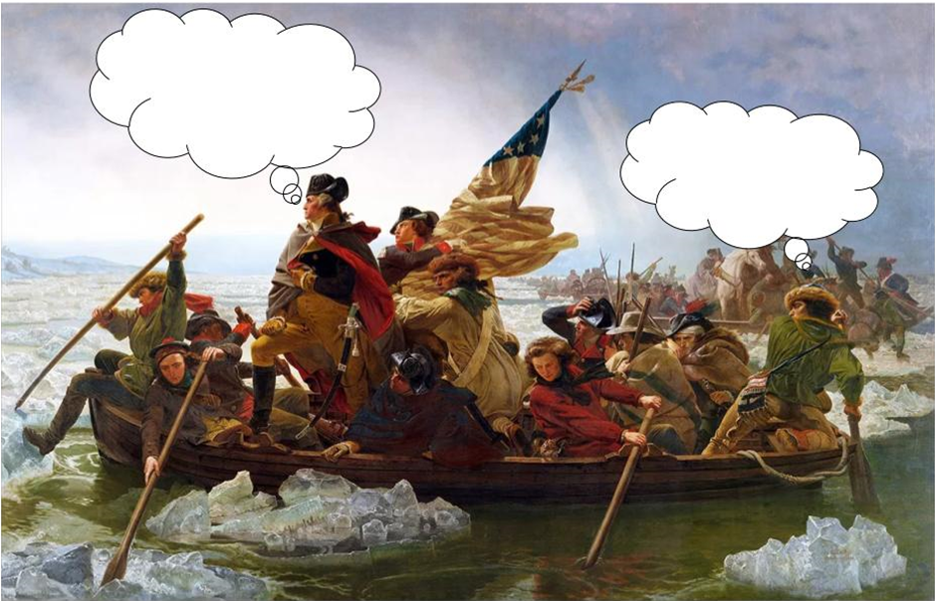
Do Now – Washington Crossing the Delaware
Directions – Use your knowledge, imagination, and creativity to add a relevant thought bubble for Washington and the soldier. Explain GW’s thought below.

- I think Washington would have thought this because… __________________________________________________________________________________________________ ________________________________________________________________________________________________________________________________________________________________________________________________________________________________________________________________________________________________________________________________________________________________________________________________________________________________________________

